**CI and CD:**

Continues integration and Continues deployment or delivery

Dev1 clone login page **dev1_branch**, dev2_branch

Dev2 clone singup page **Shared repository🡨-----🡪 CI and CD🡨----🡪 Another team**

Dev3 clone feedback **build the code**

Manager push compile, run and test

**Manager check the code. If correct developer branch code merge to main or master branch. Else they delete that branch.**

**After created shard repositor. Manager push project structure.**

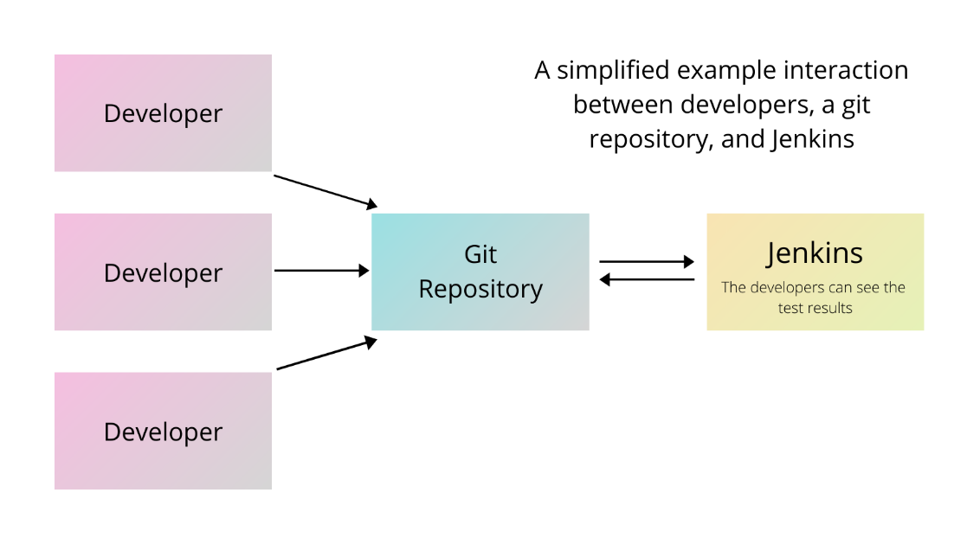

**Jenkin :** Jenkin is a type of CI and CD tool. It is an open source CI and CD tool base upon java technologies. Jenkin is plugin base CI and CD tools.